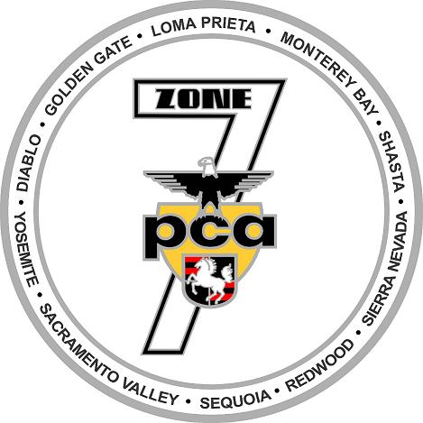
Zone 7 Presents
Two-Day Autocross School
March 26-27, 2016
Marina Airport in Marina, CA

Sponsored by Porsche of Livermore
3100 Las Positas Road, Livermore, CA 94551
855.850.3340

Hosted by the Loma Prieta Region

Welcome to the 2016 autocross school, designed for people new to the autocross experience. It is the perfect event for couples because what you and your partner will learn translates directly to everyday driving and will provide an insight into your Porsche’s capabilities, thus making you a better driver.

Saturday we will concentrate on basic driving techniques; on Sunday, you will have an opportunity to apply what you have learned as you drive your Porsche on a typical autocross course.

The event is limited to PCA members. The fee is $120.00 per person for both days and includes lunch, an event tee shirt, a copy of the book “The Art of Solo Racing” by Henry A. Watts, and instruction from some of the best and most experienced autocrossers in the United States.

Register on line at www.motorsportReg.com PCA-Zone 7 Autocross.

The course is limited to 50 students.

For further information contact:

Vern Thomas
verngoesfast@gmail.com
925-681-8290

